01223 841 841

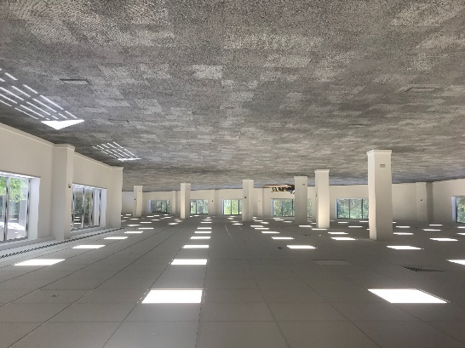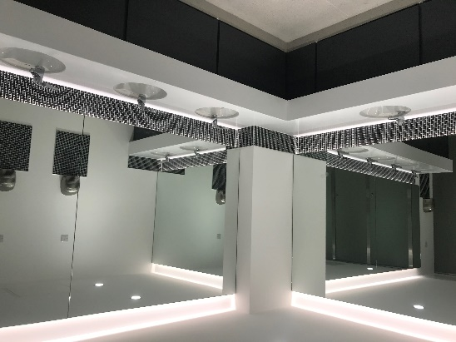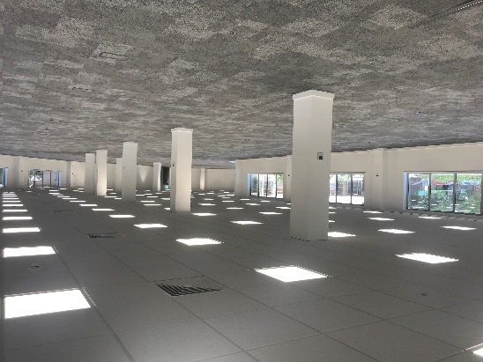bidwells.co.uk

Ground floor, unit 332, cambridge science park, milton road, cambridge

to let

In Brief

* World renowned Cambridge Science Park address
* Comprehensively Refurbished
* Available now

Offices – 9,365 sq ft (870 sq m)

01223 841 841

bidwells.co.uk

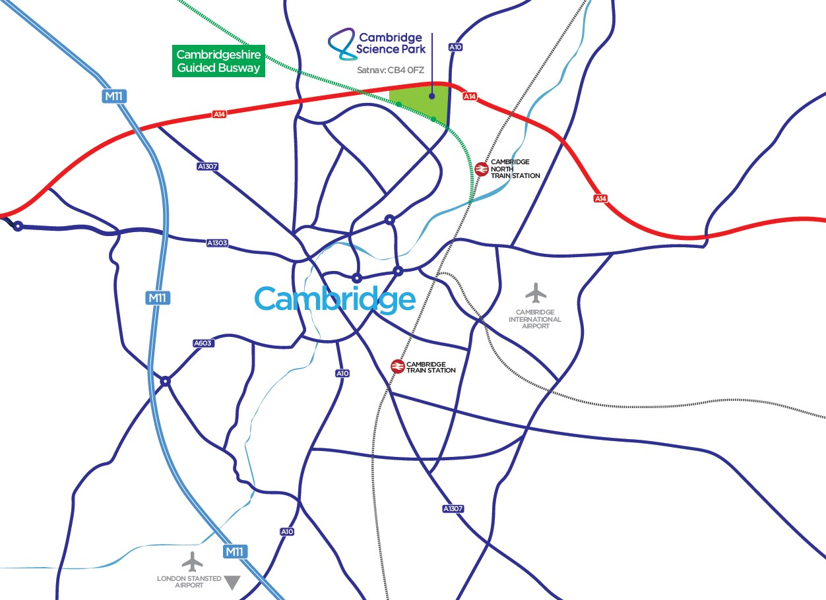

**Important Notice**   
Bidwells LLP act for themselves and for the vendors/landlords of this property, whose agents they are, give notice that:

Nothing contained in these particulars or their contents or actions, both verbally or in writing, by Bidwells LLP form any offer or contract, liability or implied obligation to any applicants, viewing parties or prospective purchasers of the property to the fullest extent permitted by law and should not be relied upon as statements or representative of fact. No person in the employment of Bidwells LLP or any joint agents has authority to make or give any representation or warranty whatever in relation to this property. Any areas of measurements or distances are approximate. The text, photographs and plans are for guidance only, may not be to scale and are not necessarily comprehensive. No assumptions should be made that the property has all necessary planning, building regulation or other consents. Bidwells LLP has not carried out a survey, nor tested the services, appliances or facilities. Purchasers must satisfy themselves by inspection or otherwise. All rentals and prices are quoted exclusive of VAT unless otherwise stated.

Prospective purchasers and tenants will be asked to produce identification of the intended purchaser/tenant and other documentation in order to support any conditional offers submitted to the vendors. Bidwells LLP accepts no liability of any type arising from your delay or other lack of co-operation. We may hold your name on our database unless you instruct us otherwise.

OS licence no. ES 100017734. © Copyright Bidwells LLP 2017. Bidwells LLP is a limited liability partnership registered in England and Wales (registered number OC 344553). Registered office is Bidwell House, Trumpington Road, Cambridge CB2 9LD where a list of members is available for inspection. Your statutory rights are not affected by this notice.

EPC

Available upon request.

Postcode

CB4 0WN

Enquiries

Max Bryan

01223 559485

[Max.bryan@bidwells.co.uk](mailto:Max.bryan@bidwells.co.uk)

Jack Vestey

01223 559315

[Jack.vestey@bidwells.co.uk](mailto:Jack.vestey@bidwells.co.uk)

Rates

Interested parties are advised to make contact with South Cambs District Council on 03450 450 500.

Legal Costs

Each party to bear their own legal costs.

Value Added Tax

All prices, premiums and rents etc. are quoted exclusive of VAT at the prevailing rate.

Additional Information

Accommodation

Ground Floor (GIA) – 9,365 sq ft (870 sq m)

Location

Cambridge Science Park is located 2 miles from Cambridge city centre, strategically positioned between junction 32 and 33 of the A14 dual carriageway on the northern fringe of the city, just 3 miles east of the M11 (junction 14) and 35 miles north of Stansted Airport. Fast rail connections are provided from Cambridge train station to London King's Cross and Liverpool Street.

Cambridge Science Park is a global centre for R&D activity. Across 150 acres and c. 2 million sq ft of high technology and laboratory buildings. It’s home to c. 7000 people at over 130 companies, ranging from exciting start-ups to some of the world's leading technology and Life Sciences businesses.

Occupiers at the park have the benefit of an on-site childcare nursery, fitness centre, catering and conference facilities, restaurant and bar landscaped grounds and access to networking groups.

Description

Unit 332 Cambridge Science Park provides comprehensively refurbished ground and first floor accommodation and benefits from the following:

* Multi let building
* VRF AC system
* Suspended ceilings
* WC and disabled WC
* Showers
* Car parking spaces – Ratio 1:430sq ft
* Carpeted throughout
* Cycle storage
* Raised floors

Terms

A new Lease is available for a term to be agreed directly with the Landlord.

Full details and quoting terms are available upon application.

01223 841841

bidwells.co.uk

1223 559352

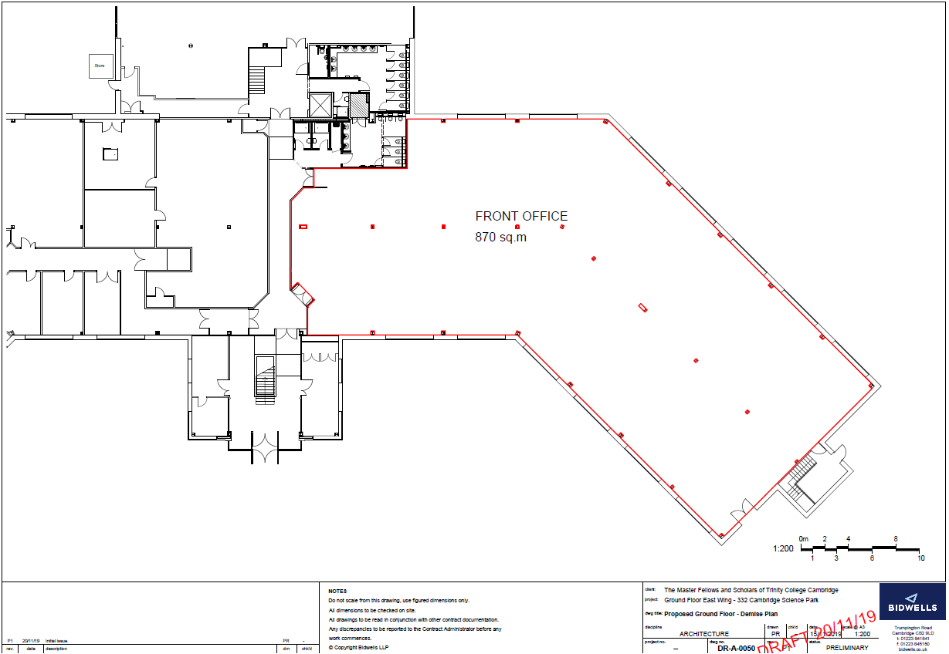

01