01223 841 841

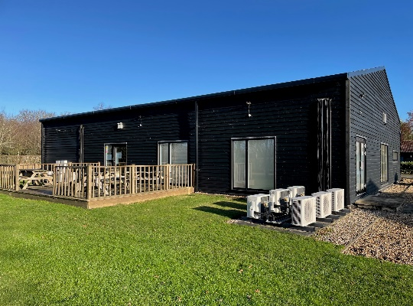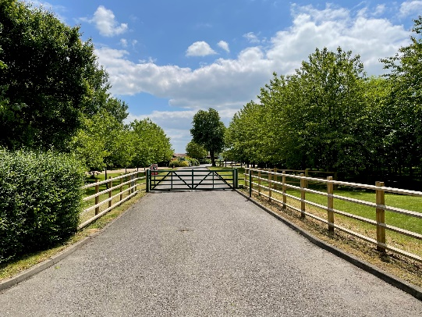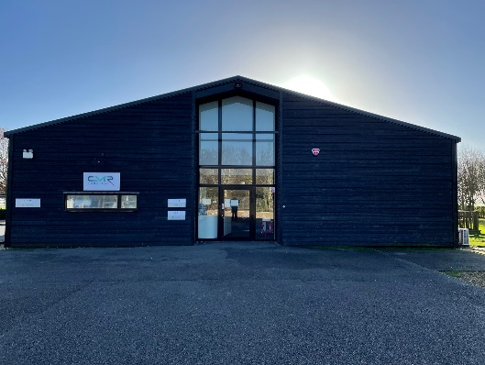bidwells.co.uk

unit 1, crome-lea business park, cb23 7ph

to Let

In Brief

* Beautiful natural surroundings
* Picturesque views with landscaped grounds
* Open plan office with meeting rooms
* WCs and kitchen facilities
* 12 parking spaces in addition to an overflow car park
* Available: June 2022

Office – c 2,700 sq ft (c 250 sq m)

01223 841 841

bidwells.co.uk

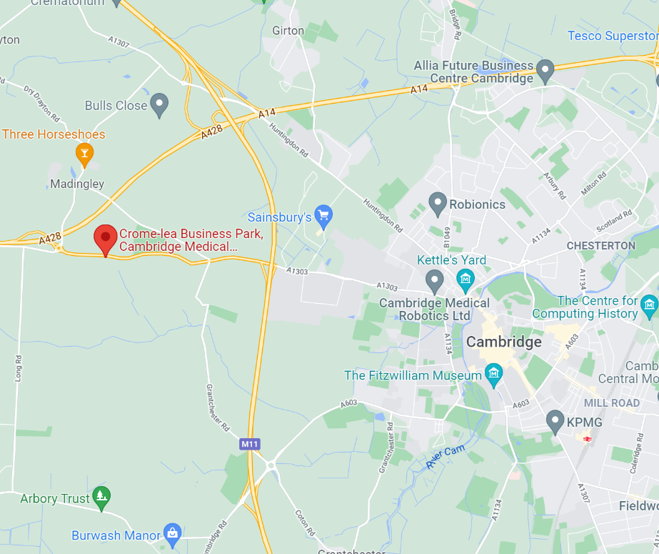

Location

Unit 1 is located in a prominent position on Crome Lea Business Park an established business park home to UK unicorn Cambridge Medical Robotics. The Park is located on Madingley Road just 5 miles to the west of Cambridge’s City Centre. The Park benefits from an elevated position providing picturesque views over Cambridgeshire.

The A1303 provides access into the city centre whilst also linking directly to the M11.

Crome Lea Business Park benefits from local amenities such as the Sports Centre located within the University West Campus, Sainsburys supermarket, The Three Horseshoes and The Plough.

Description

The property benefits from a tenant fit out in situ, the spaces layout is open plan office with meeting rooms, reception, kitchen and breakout space. Externally the property includes a breakout area on the decking.

The property benefits from the following features

* WC and kitchen facilities
* Reception area
* Perimeter trucking and raised floors in areas
* Generous on-site parking
* Meeting rooms
* External decking
* Heating and cooling

Accommodation

The accommodation provides the following net internal area:

**Sq m Sq ft**

**Ground Floor 250 2,700**

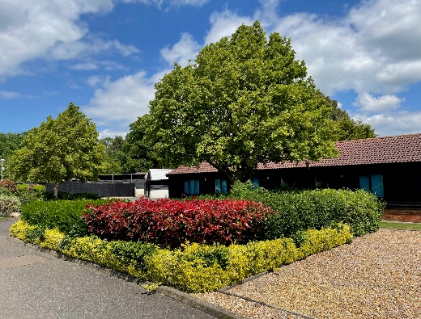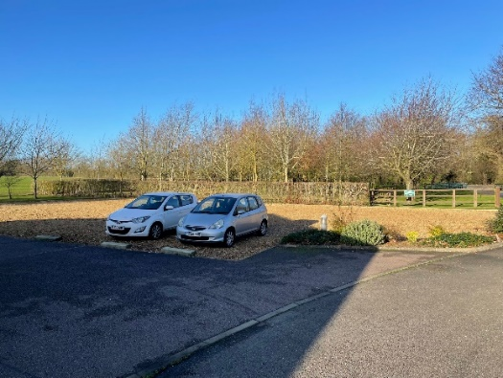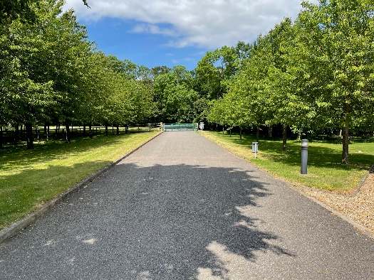

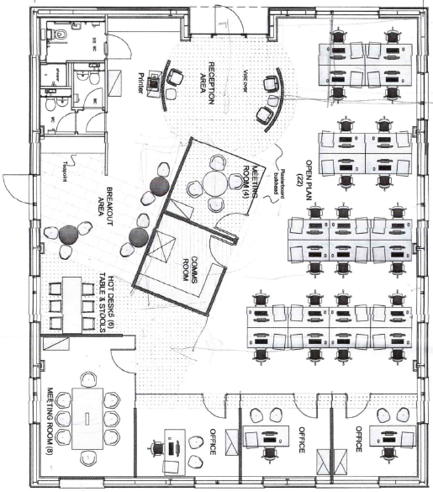

**Floor Plan**

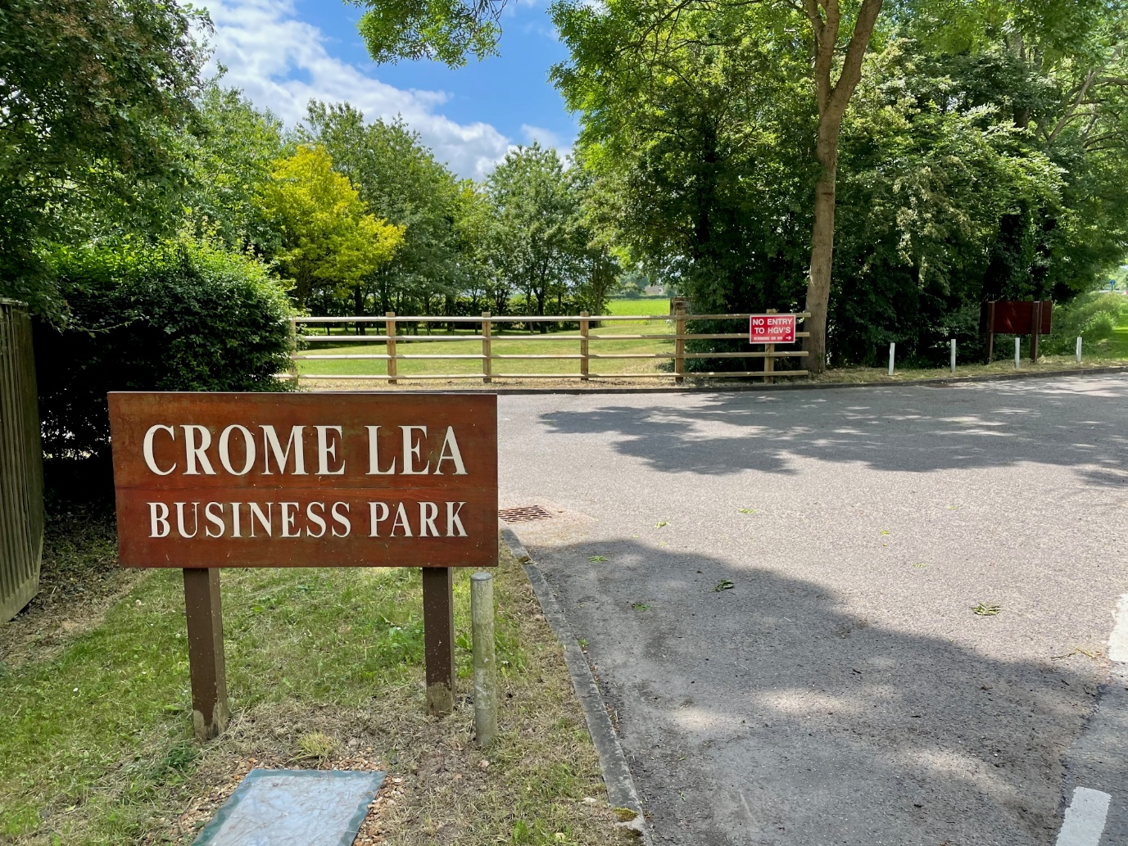

EPC

Available upon request.

Postcode

CB23 7PH   
 **Enquiries**

Harry Blevins

07467 745774

[harry.blevins@bidwells.co.uk](mailto:harry.blevins@bidwells.co.uk)

George Craig

07779 770902

[george.craig@bidwells.co.uk](mailto:george.craig@bidwells.co.uk)

Terms

The property is available on a new effective full repairing and insuring lease for a term to be agreed.

Business Rates

All interested parties are advised to make their own enquiries of Cambridge City Council on 01223 457 000.

Legal Costs

Each party to bear their own legal costs.

Additional Information